Nerissa Clarke

Project Description

SAVI 780

1. Final Project Description

I would like to create a map that illustrates different industries across the country

1. Map most prominent industry by region (multiple colors).
   1. Color intensity based on % of region
   2. I’d like for there to be a filter so that you can show each industry separately or together
      1. Each industry separately will be easy: % of employed population over 16 in industry within region
      2. For the all industry category only show the most prominent industry (might be hard to wrangle the data in this way)
   3. Add hover that includes a list of top 5 industries, median income, & maybe some other interesting economic indicators
2. Data Sources
   1. IPUMS: <https://cps.ipums.org/cps/>
   2. Census American Community Survey: DP 03, Selected Economic Characteristics (2015): <https://factfinder.census.gov/faces/tableservices/jsf/pages/productview.xhtml?pid=ACS_15_1YR_DP03&prodType=table>
3. Hurtles to overcome
   1. A lot of the counties are missing. Are states granular enough? How do I make a map with so much missing data?
   2. The way the industry data is set up (% of counties in industry) not a variable with most prominent industry
4. Other Notes/Comments
   1. If I have roadblocks: this is my alternative
      1. By State
         1. Look at indicators related to receipt of government services
            1. % of area with Social security
            2. % of area with cash public assistance
            3. % of area with Food Stamps/SNAP
            4. % of area with SSI
         2. % of government services compared to taxes collected (OMB Data, Pew data)

<http://github.com/GITSavi/Module_III>

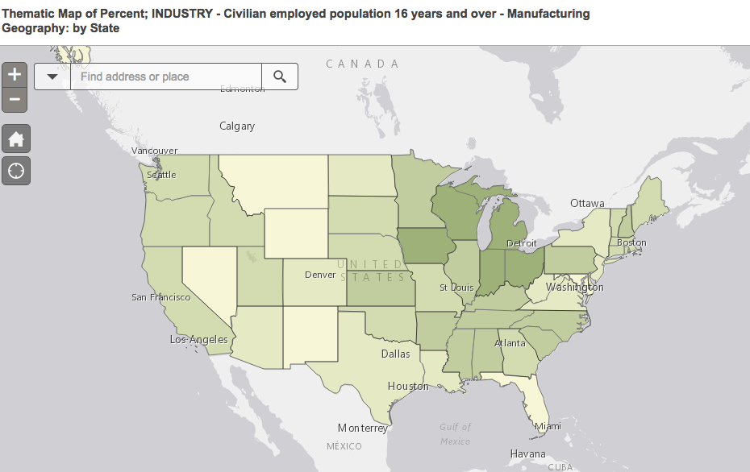

county:

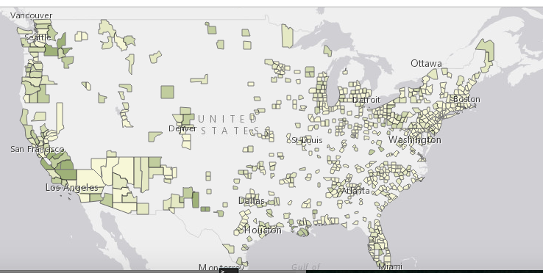

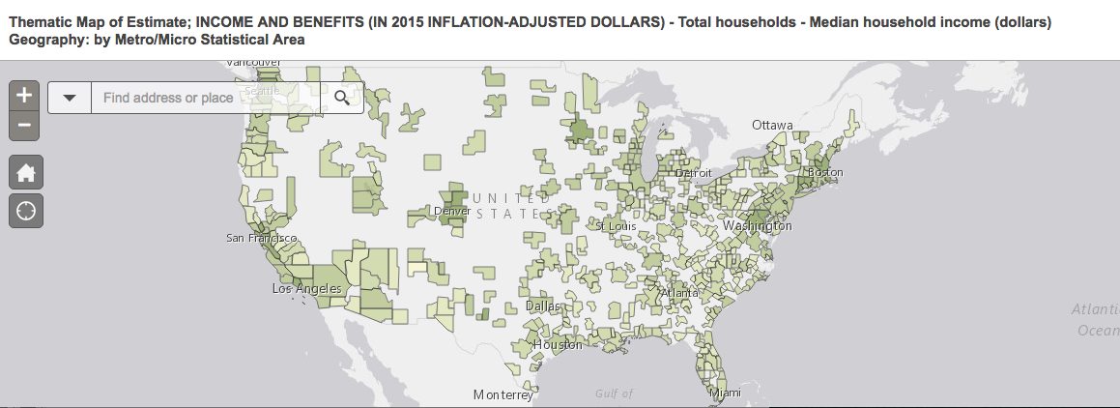

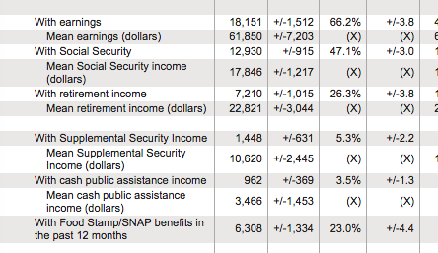

<https://www.washingtonpost.com/news/wonk/wp/2016/11/22/donald-trump-lost-most-of-the-american-economy-in-this-election/>

with EITC

with Child Tax Credit